Q-1 Transforing the data from xml file to the xslt file and display data into the grid view control into it.

Out.xml

<?xml version="1.0" standalone="yes"?>

<NewDataSet>

<Customers>

<name>Yash </name>

<email>ypatel </email>

<address>mno </address>

</Customers>

<Customers>

<name>Mahul </name>

<email>mpatel </email>

<address>STD </address>

</Customers>

<Customers>

<name>MNO </name>

<email>Ovora </email>

<address>pst </address>

</Customers>

<Customers>

<name>Mahesh </name>

<email>mkava </email>

<address>ABC </address>

</Customers>

<Customers>

<name>Vipul </name>

<email>vShah </email>

<address>sss </address>

</Customers>

<Customers>

<name>Partik </name>

<email>PSharama </email>

<address>ff </address>

</Customers>

<Customers>

<name>Utsav </name>

<email>uGohel </email>

<address>AAA </address>

</Customers>

<Customers>

<name>Vishal </name>

<email>vKalathiya</email>

<address>HHH </address>

</Customers>

<Customers>

<name>Vivek </name>

<email>vPatel </email>

<address>pqrst </address>

</Customers>

<Customers>

<name>Tom </name>

<email>DRoye </email>

<address>ab </address>

</Customers>

<Customers>

<name>Love </name>

<email>lHushan </email>

<address>oop </address>

</Customers>

</NewDataSet>

ContriesXslt.xslt

<?xml version="1.0" encoding="utf-8"?>

<xsl:stylesheet version="1.0" xmlns:xsl="http://www.w3.org/1999/XSL/Transform"

xmlns:msxsl="urn:schemas-microsoft-com:xslt" exclude-result-prefixes="msxsl"

>

<xsl:output method="xml" indent="yes"/>

<xsl:template match="Customers">

<Customers>

<xsl:apply-templates/>

</Customers>

</xsl:template>

<xsl:template match="Customers">

<Customers>

<xsl:for-each select="*">

<xsl:attribute name="{name()}">

<xsl:value-of select="text()"/>

</xsl:attribute>

</xsl:for-each>

</Customers>

</xsl:template>

</xsl:stylesheet>

Default.aspx.cs

using System;

using System.Collections.Generic;

using System.Linq;

using System.Web;

using System.Web.UI;

using System.Web.UI.WebControls;

public partial class _Default : System.Web.UI.Page

{

protected void Page_Load(object sender, EventArgs e)

{

Xml1.DocumentSource = Server.MapPath("Data/Output.xml");

Xml1.TransformSource = Server.MapPath("Data/ContriesXSLT.xslt");

Label1.Text = "Data Successfully transmited";

}

}

Default.aspx

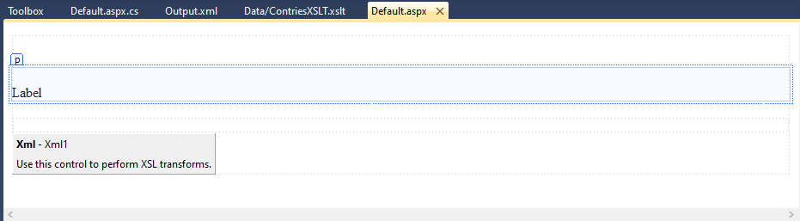

O/P:-

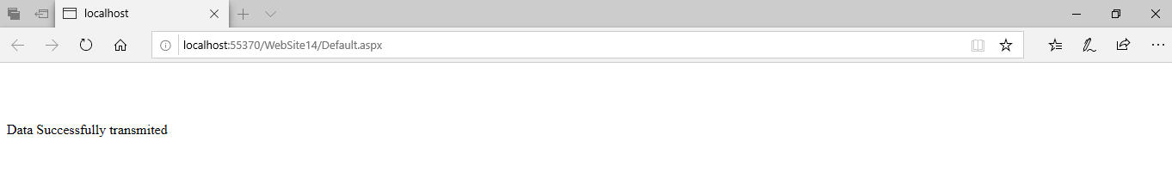

Q-2 Update the label to text after 5 seconds and label color change and time display.

Default.aspx

<%@ Page Language="C#" AutoEventWireup="true" CodeFile="Default.aspx.cs" Inherits="_Default" %>

<!DOCTYPE html PUBLIC "-//W3C//DTD XHTML 1.0 Transitional//EN" "http://www.w3.org/TR/xhtml1/DTD/xhtml1-transitional.dtd">

<html xmlns="http://www.w3.org/1999/xhtml">

<head runat="server">

<title></title>

</head>

<body>

<form id="form1" runat="server">

<p>

&nbsp;</p>

<p>

<asp:ScriptManager ID="ScriptManager1" runat="server">

</asp:ScriptManager>

</p>

<asp:UpdatePanel ID="UpdatePanel1" runat="server">

<ContentTemplate>

<asp:Label ID="Label1" runat="server" Text="Label"></asp:Label>

</ContentTemplate>

</asp:UpdatePanel>

<p>

<asp:Timer ID="Timer1" runat="server" Interval=5000 ontick="Timer1_Tick">

</asp:Timer>

<br />

</p>

<p>

&nbsp;</p>

<p>

&nbsp;</p>

<p>

&nbsp;</p>

<div>

</div>

</form>

</body>

</html>

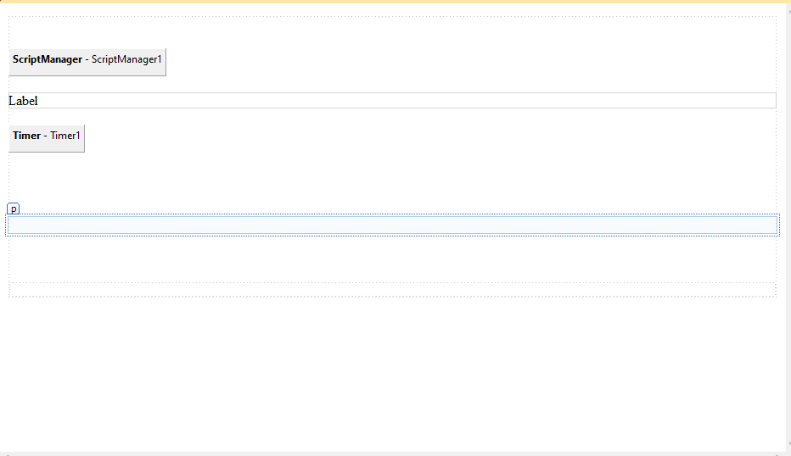

Default.aspx.cs

using System;

using System.Collections.Generic;

using System.Linq;

using System.Web;

using System.Web.UI;

using System.Web.UI.WebControls;

using System.Drawing;

public partial class _Default : System.Web.UI.Page

{

protected void Page_Load(object sender, EventArgs e)

{

}

protected void Timer1_Tick(object sender, EventArgs e)

{

Label1.ForeColor = Color.Blue;

Label1.Text = DateTime.Now.ToString();

}

}

O/P:-

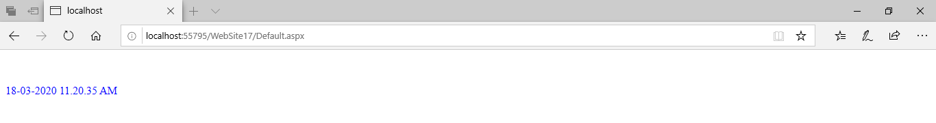

Q-3 Implementatation of data connectivity using ajax.

Default.aspx.cs

using System;

using System.Collections.Generic;

using System.Linq;

using System.Web;

using System.Web.UI;

using System.Web.UI.WebControls;

using System.Drawing;

using System.Data.SqlClient;

using System.Data;

public partial class _Default : System.Web.UI.Page

{

string connStr = "Data Source=THISPC\\SQLEXPRESS;Initial Catalog=St;Integrated Security=True;Pooling=False";

SqlCommand cmd = new SqlCommand();

SqlConnection con;

SqlDataAdapter sqlda;

protected void Page_Load(object sender, EventArgs e)

{

}

protected void Timer1_Tick(object sender, EventArgs e)

{

SqlConnection con = new SqlConnection("Data Source=THISPC\\SQLEXPRESS;Initial Catalog=St;Integrated Security=True;Pooling=False");

con.Open();

sqlda = new SqlDataAdapter("select * from tbl_save", con);

DataSet ds = new DataSet();

sqlda.Fill(ds);

GridView1.DataSource = ds;

GridView1.DataBind();

}

}

Default.aspx source code

<%@ Page Language="C#" AutoEventWireup="true" CodeFile="Default.aspx.cs" Inherits="_Default" %>

<!DOCTYPE html PUBLIC "-//W3C//DTD XHTML 1.0 Transitional//EN" "http://www.w3.org/TR/xhtml1/DTD/xhtml1-transitional.dtd">

<html xmlns="http://www.w3.org/1999/xhtml">

<head runat="server">

<title></title>

</head>

<body>

<form id="form1" runat="server">

<p>

&nbsp;</p>

<p>

<asp:ScriptManager ID="ScriptManager1" runat="server">

</asp:ScriptManager>

</p>

<asp:UpdatePanel ID="UpdatePanel1" runat="server">

<ContentTemplate>

<asp:GridView ID="GridView1" runat="server">

</asp:GridView>

</ContentTemplate>

</asp:UpdatePanel>

<p>

<asp:Timer ID="Timer1" runat="server" Interval=5000 ontick="Timer1_Tick">

</asp:Timer>

<br />

</p>

<p>

&nbsp;</p>

<p>

&nbsp;</p>

<p>

&nbsp;</p>

<div>

</div>

</form>

</body>

</html>

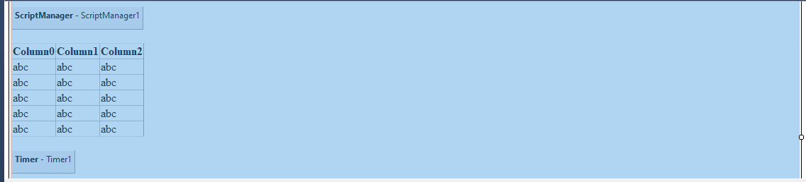

O/P:-

